Project Report

***Covid 19 impact Analysis***

**Name** :- Shaikh Aman Hshim

**Project Name** :- Covid 19 impact Analysis

**Date** :- 5 December 2024

**Technology** :- Language “ Python”

**Library** :- NumPy, Pandas, Matplotlib, Seaborn,Plotly

## Project Description

The primary goal of this project is to analyze the multifaceted impact of the COVID-19 pandemic across different domains, such as public health, economy, education, mental health, environment, and social dynamics. The insights gained will help stakeholders in policymaking, planning, and implementing mitigation strategies for future pandemics.

## Data Dictionary:

### **date :** Date of data collection

* **Country :** Name of country

### **new_cases:** New confirmed COVID-19 cases

* **Total_cases:** Total cumulative confirmed case
* **New_deaths**: new deaths reported
* **Total_Deaths:** total cumulative deaths

### **Recovery_rate:** recovery percentage of total case

* **Vaccination_rate :**percentage of vaccinated population

## Key Objectives:

#### Public Health impact:

* Analysis of infection rates, hospitalization, and mortality trends
* Evaluation of healthcare system strain, including resource allocation and response time
* Study of vaccination campaigns and their effectiveness.

#### Economic impact:

* Investigation of unemployment rates, GDP fluctuations, and global trade disruptions.
* Sector-specific analysis (e.g., tourism, retail, and healthcare).
* Assessment of government stimulus packages and fiscal policies

#### Educational Disruption:

* Examination of school closures and the rise of online learning.
* Analysis of the digital divide and its effects on education equity.
* Long-term impacts on student performance and dropout rates.

#### Mental Health and well being:

* Study of increased anxiety, depression, and other mental health issues.
* Impact of social isolation and lockdowns on different demographic groups.
* Evaluation of mental health resources and support systems.

## Potential Insights:

* **Spread Patterns**: Identification of regions with the fastest virus spread and the factors contributing to high infection rates (e.g., population density, healthcare access).
* **Vaccine Effectiveness**: Correlation between vaccination rates and a decline in new cases or mortality.
* **Healthcare Preparedness**: Insights into healthcare system weaknesses, such as shortages of ICU beds, PPE, and medical staff.
* **Public Health Measures**: Evaluation of the effectiveness of lockdowns, mask mandates, and travel restrictions in controlling the virus.
* **Income InequalitSectoral Impact**: Identification of industries most affected (e.g., tourism, hospitality) versus those that thrived (e.g., e-commerce, technology).
* **Economic Recovery**: Insights into which countries or regions recovered fastest and the e**y**: Understanding how the pandemic widened income gaps, with low-income workers being disproportionately affected.
* **Unemployment Trends**: Analysis of job losses during lockdowns and the impact of government interventions on employment rates.

# Additional Sections for Your Project Report

## Methodology

#### Literature Review:

* Review existing studies, reports, and publications on COVID-19's impact.
* Identify gaps in current research that your project aims to address.
* Use reputable sources such as WHO reports, government publications, and academic journals.

#### Data collection:

* **Primary Data:** Collect original data through surveys, interviews, or focus groups with affected stakeholders (e.g., healthcare workers, businesses, students).
* **Secondary Data:** Utilize existing data from sources such as:
* Government health departments.
* Economic reports (e.g., unemployment rates, GDP data).

#### Data processing and preparation:

* Clean and preprocess the collected data (e.g., handling missing values, standardizing formats).
* Perform data transformation if needed (e.g., normalization, aggregation).
* Ensure data privacy and ethical considerations when handling sensitive information.

#### Impact Assesment:

* **Public Health:**
* Analyze infection, recovery, and fatality rates.
* Evaluate healthcare system responses and capacity challenges.
* **Economy:**
* Assess impacts on employment, industries, and GDP.
* Examine stimulus measures and their effectiveness.
* **Education:**
* Evaluate shifts to remote learning and access disparities.

#### Data Analysis

### **Descriptive Analysis**

* **Theory:** Descriptive statistics provide a foundation by summarizing the data and identifying trends and patterns.
* **Key Concepts:**
  + Measures of central tendency (mean, median, mode) for metrics like infection rates or GDP.
  + Measures of dispersion (variance, standard deviation) to understand variability in impacts.
  + Visualization tools (time series, histograms, heatmaps) to represent data trends over time or geography.

#### Results and Discussion:

The U.S. saw a decline in life expectancy by ~2 years in 2020.

US has highst GDPA before covid 19

#### Future Work:

* **Additional Analysis:** Suggest potential areas for further analysis, such as customer segmentation, predictive modeling, or sentiment analysis.
* **Data Enrichment:** Explore the possibility of incorporating additional data sources (e.g., weather data, competitor information) to enhance your analysis.
* **Technological Advancements:** Discuss potential applications of emerging technologies (e.g., machine learning, artificial intelligence) in future research.

# Project Snapshot

1. This graph shows Countries with Highest Covid Cases

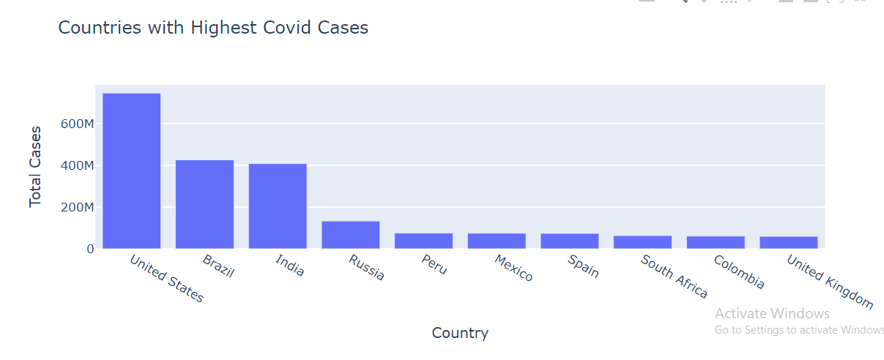

1. This graph shows countries with highest deaths

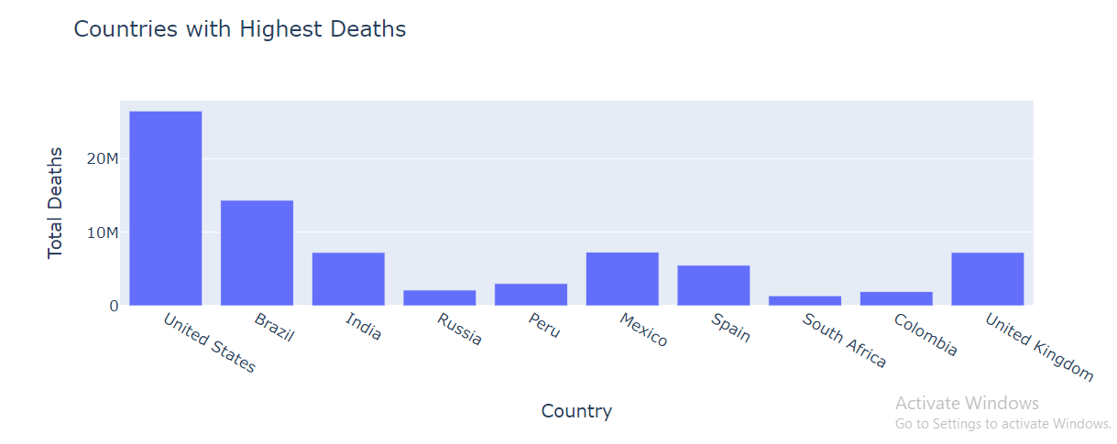

1. This graph shows Percantage of total cases and deaths

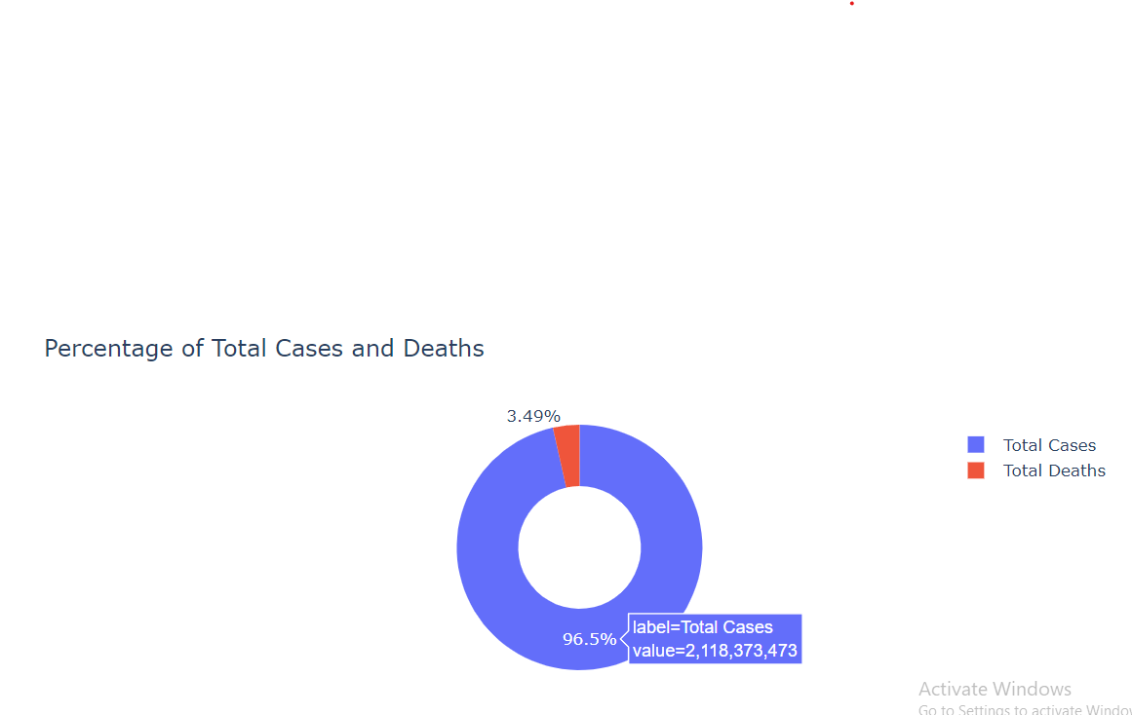

1. From this graph shows Stringency Index during Covid 19

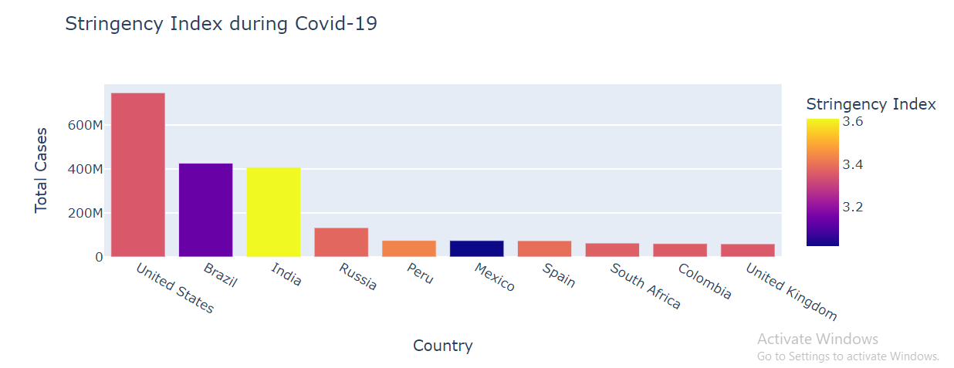

5.This graph shows GDP per Capita Before Covid-19

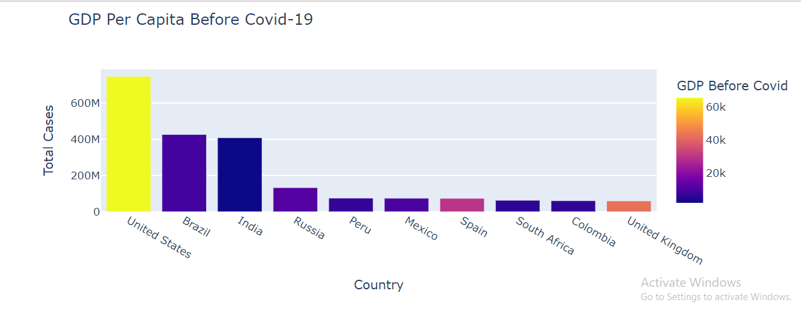

* 1. From this graph shows GDP per Capita During Covid-19

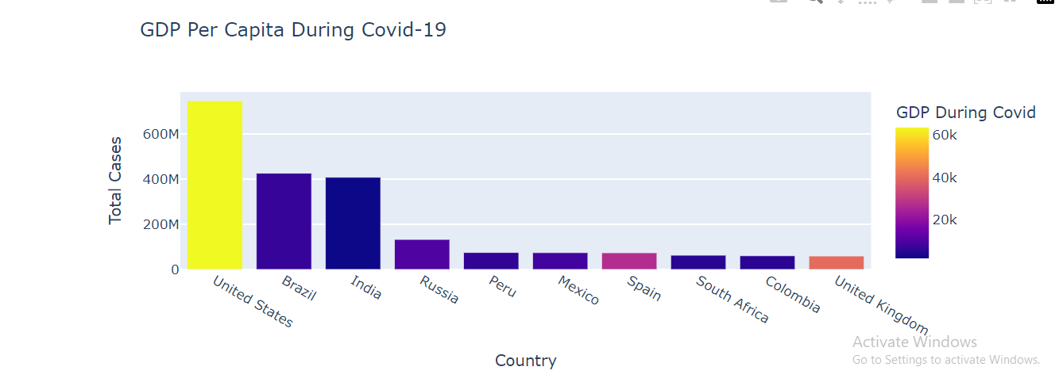

7. From this graph you can see that Human Development Index Covid-19

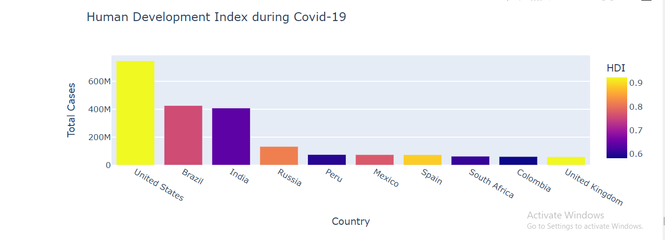

**Conclusion:**

In this task, we studied the spread of covid-19 among the countries and its impact on the global economy. We saw that the outbreak of covid-19 resulted in the highest number of covid-19 cases and deaths in the united states. One major reason behind this is the stringency index of the United States. It is comparatively low according to the population. We also analyzed how the GDP per capita of every country was affected during the outbreak of covid-19. I hope you liked this article on Covid-19 impacts analysis using Python. Feel free to ask valuable questions in the comments section below.